Replace **<your-name>** with your **name** throughout the Lab.

1. SSH to the **haproxyVM on Azure or any of the master NODE** of the 3 AWS Clusters

|  |
| --- |
| $ sudo su  # vim dotnet_app-<your-name>.yaml |

**2. Paste the below script in the dotnet_app.yaml**

Update the image: **lovescloud/docker.net.demo:latest** and replace <yourname> with your namein the below script with your dockerhub image name that you uploaded to docker hub in docker lab Pushing images to docker Hub for dotnet.

|  |
| --- |
| apiVersion: apps/v1  kind: Deployment  metadata:  name: dotnetapp-<your-name>  spec:  selector:  matchLabels:  run: dotnetapp-<your-name>  replicas: 2  template:  metadata:  labels:  run: dotnetapp-<your-name>  spec:  containers:  - name: dotnetapp-<your-name>  image: lovescloud/docker.net.demo:latest  ports:  - name: port80  containerPort: 80  ---  apiVersion: v1  kind: Service  metadata:  name: dotnetapp-<your-name>  labels:  run: dotnetapp-<your-name>  spec:  type: NodePort  ports:  - name: port80  port: 80  protocol: TCP  selector:  run: dotnetapp-<your-name> |

**Save and exit by pressing the ESC key and type wq to save and quit by pressing enter**

3. Run the below commands to deploy the .NET application on your Kubernetes Cluster

|  |
| --- |
| # kubectl apply -f dotnet_app.yaml |

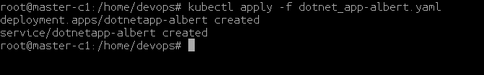

4. Get the POD deployment details by running the below command.

|  |
| --- |
| # kubectl get po -o wide |



5. Check the NODE where your app has been deployed.

**Example**

6. Check the NODEPORT on which your app has been exposed.

|  |
| --- |
| # kubectl get svc |

**Example**

**I**n this example the dotnet application has been exposed on port 31178 as shown in the below.

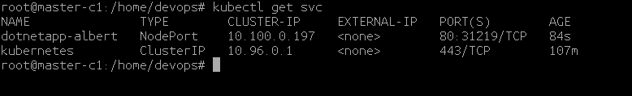

In this example the app has been deployed to the NODE **worker-1 and master-2.**

7. Login to the Azure/AWS portal and check the public IP of the NODE ( ex worker-1) access the dotnet application web page from the NODE Public IP address and Node Port on which it is exposed at.

http://<NODE-PUBLIC-IP>:NODEPORT

Example.

[**http://104.211.190.106:31219/**](http://104.211.190.106:31178/)

